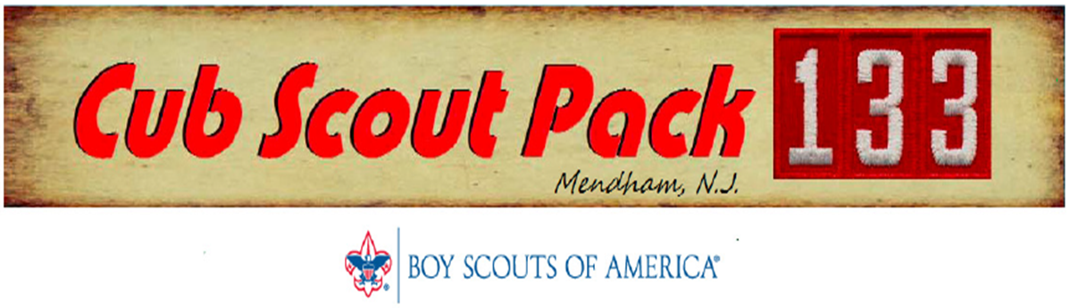

Upcoming Events:
February 2016 and beyond…
February Core Value: Friendly
Scouting Adventure: Friends Near and Far
A Scout is a friend to everyone, even people who are very different from him.
He is a brother to other Scouts. He offers his friendship to people of all races and nations and respects the beliefs and customs of others. “Friends Near and Far” reminds us that we are part of something bigger than our own community. By living the Scout Law, we are accepting of the world’s peoples and their values.
Please take some time to discuss this with your scout.
Special Notes…
… We are having some really bad luck with camping this year, aren’t we? Although five families did decide to head up to Camp Winnebago last weekend, the original 6 – 8” forecast, obviously ended up being a little more. In the end, parents and kids alike had a really good time and we all made it home safe.
… The anniversary of Scouting in America is coming up starting with Scout Sunday on February 7th and culminating with Scout Sabbath on February 13th. See below for more information on some of the services that our scouts will be involved in during this Week of Scouting.
… with that said, we usually hold our Blue & Gold Event as a celebration of the birth of Scouting, during this week also, however, due to scheduling conflicts we will be moving this event to April. Stay tuned for more information.

Pack Activities & Dates to Remember:
- January Pack Meeting
Date: Friday January 29
Time: Immediately after the Pinewood Derby checkin and impoundment
Location: Mendham Township Middle School (new location!!!) – 16 Washington Valley Road, Brookside
What: We will have a modified pack meeting following our Pinewood Derby checkin and impoundment.
- Pinewood Derby
Date: Saturday January 30 (check-in, inspection and impound, Friday January 29)
Time: See below
Location: Mendham Township Middle School
What: Cub Scouts, start your engines!!! Get ready for our annual Pinewood Derby race.
Friday night Check in times:  6:00pm – Bear  6:30pm – Tiger/Wolf  7:00pm – Webelos/AOL  Pack Meeting to begin at 7:30pm  Scouts should wear Pack T-shirts to pack meeting  Please register your car during the time indicated above for your rank. All rules for derby are on the pack website. | Saturday Race times:  10:00am – Webelos/AOL  11:00am – Tiger/Wolf  12:00pm – Bear  1:15pm – Winner photo with Township Mayor  1:20pm – Finals  Immediately following finals – Sibling Race  Although, not required, Pack T-shirts or Scout uniforms are highly encouraged, especially for photo with the Mayor (photo will be submitted to local newspaper)

- Winter Hike
Date: Sunday February 21
Time: 3pm
Location: Morristown, exact starting location to be determined
What: Our outdoor activities chair has scheduled an “Urban Historical Hike” around Morristown. Many historical events occurred around Morristown and we will visit and learn more about some of these unique sites.
Future Activities to watch for:
- Scout Week
The Anniversary of Scouting kicks off with Scout Sunday on February 7 and culminates with Scout Sabbath on February 13. Activities with local places of worship and celebrations during the week are in the planning stages. The following are in the works so far:
  - St. Joseph’s Catholic Church – Sunday February 7 at the noon mass
    - Laurel Reilly is coordinating
  - St. Mark’s Episcopal Church – Sunday February 7 at the 10am service
    - Adam Maurer is coordinating
  - Hilltop Presbyterian Church – Sunday February 21 at the 10am service
    - Jason Nolan is coordinating
If you are a member of any of the above parishes, please reach out to the person coordinating and Jason Nolan to request more information and to let us know your interest in participating.
If your family is a member of other congregations within Mendham or the surrounding area and you would like help coordinate an activity within your congregation, please reach out to Jason Nolan as soon as possible.
- Blue & Gold Celebration
Our Blue & Gold Celebration has been postponed until April. More information to come in future newsletters. If you are interested in helping to plan this event please reach out to Jason Nolan
- Spring Trip
Our Spring Trip Coordinators are working on options for our annual spring overnight trip. More details to follow.
- Spring Camping
For those of you not able to make the Winter Cabin Camping or would like to join us at Lewis Morris Park for our Spring Camping trip, this is tentatively scheduled for Saturday May 14th.
Den Leader and Committee Activities:
- Committee Meeting
Date: Wednesday February 10
Time: 7:30pm
Location: Second floor of Hilltop House
What: Continued discussions on Blue & Gold, Spring Trip and programing for March and May pack meetings along spring recruitment plans (required for all den leaders and committee members, open to all parents)
- District Roundtable
Date: Tuesday February 2
Time: Gather at 7:45pm, opening at 8pm
Location: Redeemer Lutheran Church, 203 Eyland Ave, Succasunna
What: Learn more about the next month’s core value of the Scout Law to help with your den meeting planning, network with other scouters and have fun (highly recommended for all den leaders, open to all)

As we head into spring, we will begin our spring recruitment period. Any scout that invites a friend to join scouting will receive the “Recruiter” patch to wear on their uniform. Scouts can also wear a “My family Volunteers” patch on their uniform if at least one parent is a volunteer within our pack. Please see Jason Nolan for one of these patches or for more information.

