Pack 133 Committee Meeting Minutes
Wednesday June 8, 2016 at 7:30pm – 2nd floor conference room at Hilltop House
ATTENDEES
Committee Chair – Jason Nolan | Cubmaster – Jack Kiefer | Charter Rep – Bill Lowe
Secretary – Gina Flores | Treasurer – Lauri Stroup | Publicity Chair – Tom Shaw
Advanc. Chair – Tim McChesney | Den 1 – Chris Smith | Den 2 – Laurel Reilly
Den 3 – M Moore/A Dickens | Den 4 – Eric Arena | Den 5 – Karen Keifer
Den 8 – Adam Maurer | Den 11 – Bill Gannon | Tr 150 – Laura Gill
Tr 1 – Jeff Jamer | Webmaster – Open | B&G Coord – Wendy Parrinello

BUDGET / TREASURER UPDATE
Laurie reported that there is $6506.33 in checking and $4387.00 in savings for a total of $10,893.33. There is $300.00 in Pay Pal account. The Scout Shop balance is $189.60. Tim will need funds for advancements as there will be many at the Rank Advancement ceremony. Committee discussed transfer of $1,000 for next year’s handbooks. Time will purchase and pick up handbooks. The Pack currently does banking with Wells Fargo. Laurie will look into other banks to avoid surcharges.
CHAIR REPORTS
Journey to Excellence – Jason Nolan
- Refer to spreadsheet at end of agenda
- Jason reported that Pack can possibly reach Gold again next year
Advancement – Tim McChesney
- June advancements – Tim reported that there will many rank advancements
Outdoor Activity
- Spring Hike at Jockey Hollow
  - Gina was joined by several families at the Jockey Hollow event last week
Public Relations – Tom Shaw
- Tom reported that he attended the Trade Show of Scouting. He would like to develop a better plan for public relations next year and perhaps explore options in social media (i.e. Facebook).
- Tom would like to submit an interest story on the spring trip and/or spring campout
Membership / Recruiting – Jason Nolan / Tom Shaw
- We had 6 prospective boys at recruiting event at campout
  - GeoCaching and K9 units were awesome
- Currently have membership forms from 2 of 7 potential scouts on our mailing list
- Have at least one adult parent who will register as a leader
- Council wide Rocketry event & Pack Rocketry event – Tom Saw is coordinating and event will be approximately 3 hours. Event will include assembly of rocket with a parent/guardian, launch and food.
- Lawn signs are being pick up this week
Friends of Scouting – Andi Dickens
- Goal: $2,200
- Total to date: $3,167
Training – Adam Maurer
- Update
  - Leader specific in person training – this is needed to become officially trained. This can also be taken online
    - June 11 at Council office from 12pm – 3pm
    - July 11 at Camp Wheeler from 9am – 12pm
    - October 1 at Council office from 12pm – 3pm
    - Several others if needed
      - Those who are fully trained:
        - Adam Maurer
        - Joan McChesney
        - Tim McChesney
        - Mike Moore
        - Jason Nolan
        - Laurel Reilly
        - Karen Kiefer
        - Tom Shaw
        - Chris Smith
  - BALOO Training – at least one BALOO trained leader needs to be on a
    - September 10 at Camp Wheeler from 9am – 4:30pm
    - September 17 at Camp Winnebago from 9am – 4:30pm
    - September 18 in Parsippany Area from 9am – 4:30pm
    - September 24 at Watchung Reservation from 9am – 4:30pm
    - October 1 at Camp Wheeler from 9am – 4:30pm
      - The following have BALOO:
        - Jason Nolan
        - Tom Shaw
        - Tim McChesney
  - Den Chief
    - August 28 at Berkeley Heights Rescue Squad from 1pm – 4pm
OLD BUSINESS
Service Projects:
- Bear Den 1 “Gently used Uniform drive” for a needy pack in the council – Jill Kendrick
- American Flag Drive – Adam Maurer
- Tim suggested a new service project – collecting old baseball mitts
NEW BUSINESS
Pack and Committee Meetings for 2016/2017 year
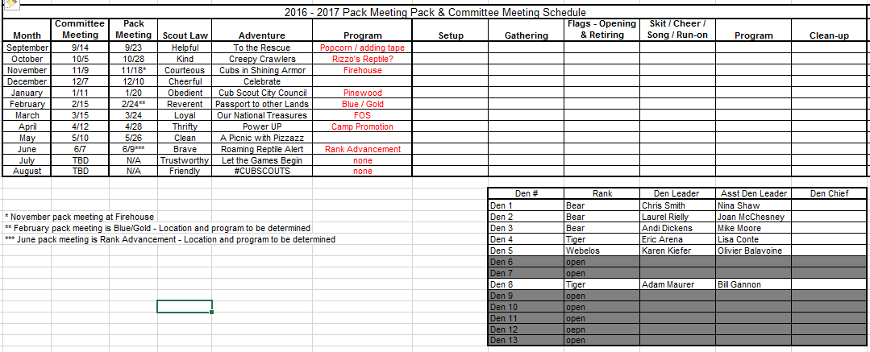
- Den involvement at pack meetings
  - We would like to utilize pack meetings for accomplishing rank or elective requirements, but will need the help of the den leaders
  - Re-introduce the den roles at pack meetings
    - Setup
    - Flags
    - Gathering activity
    - Skit/song/cheer
    - Program
    - Cleanup
  - Need ideas for activities for a couple of the months
Budget Committee
- Committee will be forming to create a budget for 2016 – 2017 and to audit 2015 – 2016 budget
Volunteers
- Popcorn
  - Show and Sell Coordinator
  - Popcorn Distribution
- Health & Safety Coordinator
- Recruiting Chair
- Webmaster
- Tom and Gina suggested using a service to improve the Pack website and possibly update the site as needed. Gina to contact web development companies and obtain information.
- Summer Activities Coordinator
- Pack Meeting Programming Chair
Summer Activities
- We are putting together a list of activities for the summer to include:
  - Parade (July 4 and Labor Day)
  - Rocketry Event – July 16
  - Staten Island Yankees – August 6
  - Fun Day in the Park – games and recruiting
  - Summer hike and/or campout
Summer Camp Spreadsheet
- We have 23 out of 60 scouts signed up for summer camp with several attending multiple weeks
- Discussion as to why that number may not be higher?
- WELOTECA
  - There are four scouts and four parents currently signed up.
  - Would like to advertise and open to any scout who would like to attend without a parent
    - We have two registered, youth protected scout leaders and two additional parents
Spring Trip:
- Need to start developing options for Spring 2017

UPCOMING PACK SPONSORED EVENTS
West Point Army Football
- Bill update?
UPCOMING COUNCIL OR OTHER EVENTS
Webelos Woods
- September 16 – registration open now

2015 – 2016 Calendar
June Rank Advancement:
- Our American Flag
Date: Friday June 10 | Setup:
Location: Mudhole | Gathering:
Time: Gather 7:15pm, begin at 7:30pm sharp | Flags:
Scout Law: Obedient | Skit / Song / Cheer:
Adventure: It’s a Hit | Program:
 | Clean-up:
 | No role:

Volunteers – there are still a lot of open positions
- The following are a list of volunteer positions that are still open (among others) in order of most urgently needed:
  - Pack meeting program Chair
    - This position will be responsible to write out an agenda for Pack Meetings and coordinate the night’s events and activities. If necessary, suggest to the committee ideas for the “Entertainment” portion of the meeting. Coordinate with the Entertainment in terms of pricing/availability/etc and materials they may need. This position should plan on attending all the pack meetings, so two people could consider sharing this role.
  - Health & Safety Chair
    - Responsible for maintaining all medical records of the pack and making sure all info is current. CONFIDENTIALITY A MUST! Work with the Pack Chair, Leaders, and Training Coordinator to make sure all adults have taken the needed training. Makes sure the Pack has a well stocked First Aid kit at all Pack Wide Events. (doesn’t need to attend, just make sure the kit is there)
  - Popcorn Kernal and committee
    - Need additional parent volunteers to assist Lynn with distribution once the popcorn arrives
  - Membership/Recruiting Chair
    - Works very closely with the Pack Committee and Committee Chair to help advertise and recruit new members into Pack 133. Helps form dens with scouts and leaders. Processes all paperwork through the proper channels. Should also be involved with rechartering.
  - Webmaster –
    - Responsible for maintaining Pack 133’s website and keeping it updated with current information
  - Summer Activities Chair
    - This position will lead the coordination of summer activities and recruiting parent volunteers to help coordinate individual events. Summer activities may include but are not limited to July 4th parade, summer baseball game, summer hikes and/or campouts, Labor Day parade, etc. Our goal is for all scouts, dens and the pack to be eligible for the National Summertime Pack Award and individual Scouter Awards
  - Conservation Chair
    - Environmental conservation is a large part of the scouting movement. We like to provide a conservation service project to a civic location located within our town. Coordinator would provide location options, dates and coordinate the scouts and any tools that may be needed.

